

*“All students are safe, known, and prepared to reach their highest potential”*

Welcome to Omak Middle School! We have an exciting educational program full of engaging and fun opportunities. Communication from school to home is critical for all students to be successful. Please take the time to thoroughly read this student/parent handbook. Being a student at OMS and being a Buckskin is something to be proud of. At OMS staff and students strive to be **G**racious, **R**esponsible, **E**ncouraging, **A**ccountable and **T**imely. Let’s be GREAT together.

***Omak Middle School Student/Parent Handbook***

**Omak Middle School**

14 South Cedar

Omak, WA 98841

(509)826-2320 (Fax) 826-7696

[www.omaksd.org](http://www.omaksd.org)

**Office Hours: 7:30am – 4:00pm**

Principal: Dr. Ryan Christoph

Assistant Principal: Lance O’Dell Director of Student Support: Audrey Hunt

School Counselor: Emilie McGaha Counseling Secretary: Elizabeth Campos

Building Secretary: Lori Coffell Attendance Secretary: Gail Thompson

***Table of Contents***

Dates to remember/School calendar 3

Staff 4

Bell Schedule/Activities 5

OMS is G.R.E.A.T. 6

General Information 7

Attendance Policy 12

Sports and Activities 14

Guidance 15

Students’ rights and responsibilities 16

Disciplinary action and due process 17

Disciplinary Action Guidelines 18

Harassment/Intimidation/Bullying policy 20

Filing complaint process 21

McKinney-Vento Homeless Educational Assistance Act 24

***Dates to remember/School Calendar***

**(School District Calendar can also be seen on the School District Web page.)**

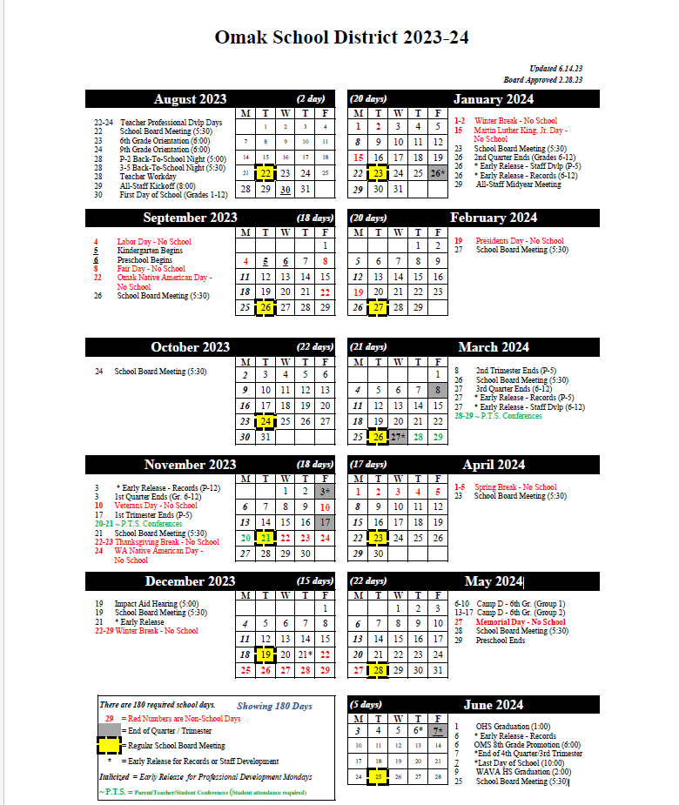

***Omak Middle School Staff***

**Principal:** Dr. Ryan Christoph **Assistant Principal (SSS):** Audrey Hunt

**Assistant Principal:** Lance O’Dell  **Counselor:** Emilie McGaha

**Instructional Coach:** Kyona Cavadini **Outreach:** Ellie Swartsel

**Secretaries Support Staff**

Lori Coffell, Building Secretary Mary Brown-Kencayd

Gail Thompson, Attendance Secretary Nic Demmitt

Elizabeth Campos, Counselor Secretary Jenee Geoghegan Bernice Guiterrez

**Special Education** Kayla Guiterrez

Leilani Beck, ELA Resource Sheila Harrison

Jennifer Smith, Math Resource Richard Lackie

Billie Johnson, Life Skills Jessica Mitchem

Sara Mullen

**ELA Teachers** Megan Nansen

Michelle Rubio, 6th /7th GradePaul Nash

Lynn Hoover, 7th Grade and Leadership Brady Tonasket

Kim Beard, 8th Grade Patrick Turner

**Science Teachers** **Student Services:** Jodee Ranes

Sidera Blue, 6th Grade

Tracie Tonasket, 7th Grade **Community Engagement:** Jordan Sackman

Nathan Moore, 8th Grade **JOM:** Pam Edmonds

**PAC Director:** Jon Winans

**Math Teachers** **OSD Psychologist:** Shelby Bohrman

Jacquie Thornton, 6th Grade **Student Assistance Professional:** Lesa EiffertWyatt Utt-Picking, 7th Grade  **Educational Advocate:**Lynell Morrison-Nelson Richey Shipley, 8th Grade

**Nurse Department**

**Social Studies Teachers** Debbie Lawrence, Nurse

Nora Kayser, 6th Grade and ELL Heidi Peterson, Nursing Secretary

Ivan Murphy-Dlouhy, 6th Grade and 6th ELA

Pat Morris, 7th Grade/PE **Maintenance Staff**

Layten Briggs, 8th Grade Tim Engh, Administrator

Jared McNeil, Assistant Administrator

**Elective Teachers** Tom Summerson

Spencer Martin, Physical Education Tracy Predoehl

Denise Gallup, Art Brian Christie

Calvin Gorman, Band

Don Pearce, Choir **Kitchen Staff**

Cary Tonasket, Computers/PE Dusty Hughes

Jessica Smith, STEAM Ryan Holt

Anthony Ruiz, STEM Shay O’Conner

Tyler Foth, STEM Sherry Whitney

***OMS Bell Schedule 2023-24***

|  |  |
| --- | --- |
| ***Monday***  *Professional Development Monday*  *(PDM)* | |
| Warning Bell | 7:55 |
| 1st | 8:00-8:52 |
| 2nd | 8:55-9:47 |
| 3rd | 9:50-10:42 |
| 4th | 10:45-11:37 |
| Lunch | 11:40-12:10 |
| 5th | 12:13-1:05 |
| 6th | 1:08-2:00 |

|  |  |
| --- | --- |
| ***Tuesday-Friday***  *Regular Schedule* | |
| Warning Bell | 7:55 |
| 1st | 8:00-8:50 |
| Intervention | 8:53-9:26 |
| 2nd | 9:29-10:19 |
| 3rd | 10:22-11:12 |
| 4th | 11:15-12:05 |
| Lunch | 12:08-12:38 |
| 5th | 12:41-1:31 |
| Intervention | 1:34-2:07 |
| 6th | 2:10-3:00 |

|  |  |
| --- | --- |
| ***2-Hour Delay*** | |
| Warning Bell | 9:55 |
| 1st | 10:00-10:42 |
| 2nd | 10:45-11:27 |
| Lunch | 11:30-12:00 |
| 3rd | 12:03-12:45 |
| 4th | 12:48-1:30 |
| 5th | 1:33-2:15 |
| 6th | 2:18-3:00 |

|  |  |
| --- | --- |
| ***Early Release*** | |
| Warning Bell | 7:55 |
| 1st | 8:00-8:40 |
| 2nd | 8:43-9:22 |
| 3rd | 9:25-10:05 |
| 4th | 10:08-10:48 |
| Lunch | 10:51-11:21 |
| 5th | 11:24-12:03 |
| 6th | 12:06-12:45 |

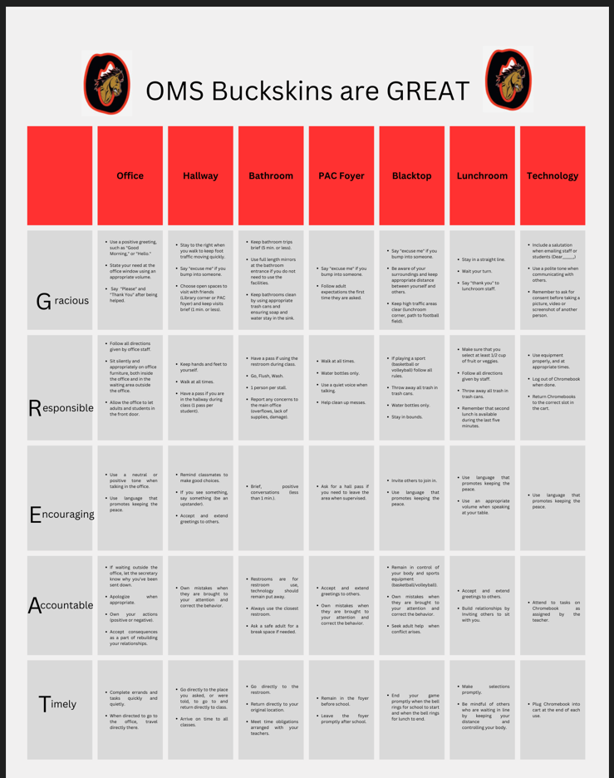

***General Information***

**ACADEMICS/Grading Practices**

Grading practices are determined by individual faculty members and will be shared with

students/parents via a class syllabus. If students have questions regarding grading practices,

they should talk to the teacher. At the conclusion of each quarter, student grades are recorded

on report cards that are given to students for their personal records and to share with their parents. A student’s grade point average or g.p.a. will be computed by a combination of the

student’s grades from each of their classes. Students will receive a high school credit for

Washington History during their 7th grade year, and this will be posted to permanent records of students at the end of the semester.

**Skyward / Checking Student Grades**

Skyward is a convenient way to check on student academic progress using the internet (from

home or school). It is an opportunity for parent(s)/guardian(s) to check to see how their student is performing academically at OMS. Skyward gives current information on grades,

assignments, attendance, etc. 24 hours a day and seven days a week.

To use Skyward:

1. Go the Omak School District website at www.omaksd.org

2. Place the cursor on “Parents”.

3. Scroll down and click on “Skyward”.

4. Type in your Login ID and Password (Login ID and Password is case sensitive). If you do not know your Login ID and Password, the Omak Middle School office can provide

them for you.

5. At the top you will see your student’s name and the school you are viewing. If you

have more than one student in the district, you will need to select the specific student.

6. To see current grades, click on “Gradebook” and click on the class you would like to

view. A couple of things to remember within the Gradebook:

a. Be sure to click on the most recent term or quarter.

b. If you see an * next to an assignment, it indicates the teacher has not entered a

grade for that assignment and that assignment is not counted as a missing assignment in their grade.

c. If you see a zero (0), it indicates that your student has not turned in that

assignment and it is counting as a zero (0) toward their grade.

Login ID: Password:

**Report Cards**

Report cards are issued every nine weeks or four times during the year. Each teacher will

explain his/her grading system in their class syllabus.

**Progress Reports**

The purpose of this report is to inform parents or guardians of their child’s progress in school.

They are sent out midway through each grading period, and others can be sent at any time

during the year. Online grades are accessible at all times. Parents should contact the office for

Skyward login information.

**Accidents**

School accidents should be reported immediately to the nearest adult in charge. If additional

help is needed, you should contact the office for further arrangements. When an accident occurs on school grounds an accident report must be filled out.

**ASB Cards**

ASB cards are available at the beginning of the school year (after picture day) in the Middle

School office. All students will be issued an ASB card at no cost. Student ASB cards are

required for participation in sports, clubs and activities. They can also be used towards

reduced prices for gate fees when visiting other schools.

**Breakfast/Lunch Program**

Family Income Survey are for all students and will be sent home at the beginning of the school

year. Breakfast and lunch are free for all students; however, the applications are necessary to

keep the breakfast and lunch program free.

**School Bus Expectations**

The Omak School District shares the responsibility with parents for student safety and

conduct to and from school. To ensure the safety of all, bus rules have been established.

The driver is in complete charge of the bus and passengers. Passengers must obey the driver

promptly at all times. Drivers, coaches, teachers and chaperones expect students to be

attentive to the rules anytime students are traveling by bus. Students not following bus

rules are subject to disciplinary action.

**Closed Campus**

Omak Middle School has a closed campus. This means no student should leave school

grounds without parent **and** school office permission. All students must follow proper

checkout procedures in the office.

**The Cafeteria**

The school cafeteria is as a vital part of the health program at the school. To encourage good

nutrition, a well-balanced lunch and breakfast are offered at no cost. The cafeteria

management and your fellow students will appreciate your cooperation in:

• Depositing all lunch litter in wastebaskets.

• Returning and stacking all trays.

• Leaving the table and floor around your place in a clean condition for others.

**Counseling**

The counselor is available for academic as well as counseling support. The counselor will help

with students’ social, physical, and emotional development. This may be done through

individual counseling, groups or through referrals to other local agencies.

**Deliveries**

We understand that parent(s)/guardian(s) will need to have essential items delivered to

their students at times during the school day. In an effort to reduce the impact on the

educational environment, students will be notified that there is something in the office for

them to pick up and it will then be their responsibility to do so. Due to many different

factors, including the potential negative impact on the educational environment, we ask that

gifts (flowers, presents, etc.) not be delivered to the school, and they will not be held at the

office for students. This will include delivery services, such as Door Dash. In situations where gifts are delivered to the office to deliver to students, Ubber Eats, and Postmates. Parent(s)/guardian(s) will be contacted and asked to make arrangements to pick up the gifts

from the office.

**Hall Passes**

Hall passes **may** be made available by the classroom teacher. Any student out of class during

instruction time **must** have a pass from the teacher including time, date, and reason for being

out of class.

**Library**

Omak Middle School will utilize the library that is located in Omak High School. The library has books, magazines, newspapers, and many other print and non-print materials

that students can access with their scheduled class. Fines are charged for lost materials.

**Dress Appearance**

Appropriate dress and grooming are expected of students. Dress and appearance is the responsibility of the parent and the student; however; dress and appearance shall not be disruptive to the educational process or learning objectives. The school is responsible for seeing that student attire does not interfere with the health or safety of any student, and that student attire does not contribute to a hostile or intimidating atmosphere for any student. Some restrictions must be necessary to support the overall educational goals of the school. A student who wears clothing that disrupts the educational process will be referred to an administrator.

**Pajamas, blankets, or other sleepwear are not considered appropriate dress for**

**school.**

1. Certain body parts must be covered for all students. Clothes must be worn in a way such that genitals, buttocks, and nipples are covered with solid material. All items listed in the “must wear” categories below must comply with this basic principle.
2. Students **MUST Wear**:

• Shirt

• Bottom: pants/sweatpants/shorts/skirt/dress/leggings

• Shoes; activity-specific shoes requirements are permitted (for example for sports).

1. Students **CANNOT Wear:**

• Violent language or images.

• Images or language depicting drugs, alcohol, and/or gang-related (or any illegal item or activity).

• Hate speech, profanity, pornography.

• Images or language that creates a hostile or intimidating environment based on any protected class.

• Visible underwear.

• Bathing suits.

• Masks or headgear that obscures the face (except as a religious observance).

**Electronic Devices**

During school hours except for lunch, students are asked not to have or use personal

electronic devices. Electronic devices must be out of sight which includes poking out of

pockets, bags or sweatshirts.

**Devices if seen will be confiscated.**

• 1st offense-Teacher discretion as to when it is returned. (End of period is encouraged if the student cooperates.)

• 2nd offense-Held by admin or in Student Services Room (SSR) until the end of the day with a phone call home.

• 3rd offense-Detention and held until a parent meeting.

**Safety Drills**

Safety drills, such as Fire and Lockdown drills, are required by law and are an important safety precaution. It is essential that when the first signal is given, everyone obeys orders promptly and follows the procedures posted in each classroom as instructed by the teacher.

**Lockers**

Lockers will not be used this school year.

**Backpacks**

Backpacks are the responsibility of the student. The school is not responsible for lost or stolen articles from backpacks or misplaced backpacks. Students will be allowed to carry backpacks with them during the school day. Upon entering a classroom, teachers may require that backpacks be placed or stored in a specific location within their classroom for safety reasons and to limit potential distractions.

**School Visitors**

Parents are encouraged to visit school at any time and are also asked to check in at the office where visitor passes will be handed out. Classroom visits must be pre-arranged with the teacher. Students’ visitors will not be allowed unless there is an education benefit to our school for the visit.

**Student Government**

The Associated Student Body of Omak Middle School is governed by elected ASB officers. ASB meetings will be scheduled before school, after school or during lunch. ASB officers and reps are open to all grade levels.

**Telephones**

The office telephone is used for school business. Student use during class time is limited to

emergencies and may only be used with office permission and a note from the teacher. During

lunch, before, and after school, students may politely ask to use the office phone.

**Tutoring and conferences**

Teachers are available before and after school from 7:30am-8:00am and 3:00pm to 3:30pm.

Each teacher’s schedule is posted outside each classroom. You may refer to this schedule to

set up a meeting during the preparation time. Students are encouraged to use this time to get

academic help, tutoring assistance, and resolve behavioral problems that occur in the

classroom. Parents are encouraged to make appointments to meet with teachers during this

time, or during the teacher preparation period. It will be the student’s responsibility to find

out the prep periods of their individual teachers.

**Dances/Activities**

Attendance at school dances is a privilege. All building and classroom rules and expectations apply to dances. Students may be removed or dismissed from a school dance if behavior does not meet expectations. All students attending a school dance must be currently enrolled at OMS.

**Office Conduct**

Students should remember that the office personnel are glad to help them, but they also have other work to do. Should a student behave rudely, speak loudly, or refuse to comply with the requests of the office staff, the student is subject to disciplinary action.

**Computers/Technology**

Student access to computers at school or use of the school network **is strictly for educational**

**purposes only.** Use of school technology in any way that is NOT school related may lead to

discipline and loss of technology use privileges. All students must have a completed

technology acceptable use policy form on file in the office.

***ATTENDANCE***

Good attendance patterns play a vital role in student success in school as well as in the world of work. Developing a habit of good attendance now will produce many positive benefits in the future. Washington State law states that students need to attend school and need to be on time. Students must also obey all rules and regulations of the school district as determined by the administration and the board of directors. In compliance with Washington State’s Compulsory Attendance Law, each student shall be expected to be in school each day except in the case of personal illness (including emergency, dental or medical appointments). Parents are discouraged from requesting a student’s absence for reasons other than prescribed by law. If absences exceed more than 20 consecutive days, the pupil will be withdrawn. (WAC 392-121-108).

1. **Class Attendance** – Each student shall report to each of his/her classes as scheduled. Failure to attend a class may result in school discipline. Students officially excused by the administration shall not be penalized. A student’s academic grade in a particular subject or course may be adversely affected because of tardiness or absences.
2. **Early Dismissal** - If it is necessary for a student to leave school early, please send a note with your student to the attendance office before school that morning or call the Attendance Office with the information. Students must report to the main office prior to leaving campus and the parent/guardian will need to sign the student out.

3. **Tardy to School** – Students arriving after 8:00am need to report to the attendance office. A note from the parent/guardian is needed to excuse the tardy. Any student who does not have a note will be considered an unexcused tardy until a note is brought in or a parent/guardian calls the attendance office.

**Tardy to class** – Promptness to class is very important. Students are to be ready to work when the bell sounds. Arriving to class after the bell rings and/or being unprepared for class will be considered tardy. Tardiness without a valid permit slip from another teacher, counselor, principal or other staff member will be considered unexcused.

1st Tardy – warning.

2nd Tardy – conversation with teacher and/or administrator if needed.

3rd Tardy – lunch detention.

At the beginning of each quarter, tardy counts will be reset.

1. **Returning to School After an Absence** – Students are required to provide a written excuse signed by a parent/guardian upon returning to school after an absence. Should a student return without a note the absence is considered unexcused until a note is sent or a parent/guardian calls the attendance office to report the absence.

1. **Withdrawing from School** – All students must have a parent/guardian request to be withdrawn. The request can be a written note or a phone call and must be from the parent/guardian who enrolled the student. If a student is present at school, they can hand carry the withdrawal papers to each class, which will allow it to be completed that day. If the student is not present it will take three days to complete the withdrawal process.

6. **Excessive Absences and Truancy** or Noncompliance with Washington’s Compulsory Attendance Law**.** Students will be asked to provide medical documentation for any prolonged illness (more than 1 week). If a student has several unexcused absences or is absent a large number of days in the school year, school officials will schedule a meeting with the parent and the student to develop a plan for improved attendance. If expectations of the plan are not met, or parents don’t respond to requests for a meeting, then a doctor’s note may be required to excuse all future absences. If this intervention does not work then a BECCA petition reporting noncompliance with Washington’s Compulsory Attendance Law will be filed with the Okanogan County Juvenile Court.

***Sports & Activities***

7th and 8th grade students may participate in all middle school sports offered through the school. 8th grade students only may compete on some, but not all, high school teams. 6th grade students may compete on some, but not all, middle school teams. All grades may participate in clubs and activities.

**Fall Sports*:**

Cross Country: 6th, 7th, and 8th grade boys and girls

Football: 7th and 8th grade boys

Volley ball: 7th and 8th grade girls

High school soccer: 8th grade girls only

**Winter Sports*:**

Boys Basketball (Before Winter Break): 7th and 8th grade

Girls Basketball (After Winter Break): 7th and 8th grade

Wrestling (After Winter Break): 6th, 7th and 8th grade

**Spring Sports*:**

Track and Field: 7th and 8th grade boys and girls

High school soccer: 8th grade boys only

High school tennis: 8th grade only, boys and girls

High school fastpitch: 8th grade girls only

High school golf: 8th grade only, boys and girls

**Clubs and Activities**

ASB Student Government, Art Club, Club Shred; Math is Cool; Yearbook; Native American Club; Builders Club; Theater/Drama Club; CTE Advisory Club; Chess club; Tech Club.

Participation in activities is a privilege and students must earn the right to participate by being

a good citizen and student as well as following the school activity/athletic code.

**\*To be eligible to participate in a middle school sport students must be registered through the Athletic Department, have an up-to-date physical and passing all their classes.**

***Guidance/Intervention Services***

Student Services personnel meet with staff, students, and their families to help evaluate

problems and to develop appropriate intervention plans. Student Services include the

following activities:

**Student Services Team**

This is a school based multi-disciplinary team for problem solving and intervention. These

problems consist of but are not limited to the following examples: academic or behavior

concerns to help determine possible interventions.

**Referral & Assessment, All Grades**

Parents, teachers, or community members who are concerned about a student may make a

referral by contacting the principal, assistant principals, or counselor at the student’s school.

Students may self-refer by contacting any staff member or counselor at their school. All

referrals are confidential as defined by state and federal statutes.

**Support Groups**

Support programs are available for students who are “at risk” of becoming chemically

dependent, and for those who are chemically dependent or who are returning from

treatment. These groups give support to the student who is attempting to be drug free.

Examples of groups include: Friendship groups, social skill groups, and after care groups.

**Drug & Alcohol Intervention Program**

**Prevention Services**

Prevention activities focus on school climate and guidance services. Students may voluntarily

ask for services.

**School Climate**

A positive school environment can help students to perform in a productive manner

(academically, social, and emotionally). The school strives to be a place where:

• Students, staff, and parents respect themselves and others

• Individuals can be trusted to do what they say they will do

• Each person feels that s/he has a voice in the decisions that affect him/her

• Everyone feels that s/he is continuing to grow and learn

• Everyone accepts and values diversity among people

• All possess a “sense of belonging”

• All feel that they can make a difference to someone else

***Student Rights & Responsibilities***

**Philosophy**

One of the major goals at Omak Middle School is to promote in each student a sense of one’s

civic rights and responsibilities. As a result of the process of education, each student should

clarify his/her basic values and develop a commitment to act upon these values within the

framework of one’s rights and responsibilities as a participant in the democratic process.

**Student Rights**

Every Omak Middle School student has the right to:

1. A safe environment

2. An equal educational opportunity regardless of national origin, race, religion, economic status or sex

3. Be free from sexual harassment or other types of harassment

4. Freedom of speech and peaceful assembly

5. Be secure in person, paper, and effects against unreasonable searches and seizures

6. Due process

7. Conference with the principal to resolve grievances

**Student Responsibilities**

Every Omak Middle School student has the responsibility to:

1. Show courtesy, pride, and respect towards others

2. Comply with the school district policies and rules

3. Do their best in their course of study

4. Submit to the authority of the teachers and staff

5. Use self-discipline

6. Accept consequences for their own actions

7. Abide by and promote the school spirit and values of the school

**Teacher Rights and Responsibilities**

Every teacher and administrator shall, in accordance with due process rights of the students,

have the authority to discipline any student for disruptive or disorderly conduct while that

student is under his/her supervision and jurisdiction.

Teachers are required to maintain a suitable environment for learning and are to set an

appropriate example of personal conduct and avoid statements, which may be demeaning or

personally offensive to any student or group of students.

**Disciplinary Action and Due Process**

Students are expected to use self-discipline and must assume responsibility for their behavior.

When a student’s behavior is not acceptable, disciplinary action may be issued. Discipline shall mean all forms of corrective action or punishment other than suspension or expulsion. Suspensions and expulsions can only be assigned by administration. Teachers and administrators have authority to control and/or discipline a student during the time the student is in attendance or in transit to or from school or any school sponsored function. The following corrective actions or punishments include, but are not limited to:

**Detention time:**

The student is assigned to report to a teacher or the office to resolve a problem. The student may also be assigned detention before or after school or during lunch. A student is given a least one day’s notice when detention time is assigned so that he/she can arrange transportation.

**Emergency Removal**

A student may be removed immediately from a class, subject, or activity by a teacher or

administrator provided that the teacher or administrator has good and sufficient reasons to

believe the student’s presence poses an immediate and continuing danger to the student,

other students or school personnel or an immediate and continuing threat of substantial

disruption of the class, subject, activity, or educational process of the student’s school.

**After School Detention**

Each teacher or administrator shall have the right to assign a student to after school detention. Students must report and sign in to the detention room by 3:05pm on the day assigned. If a student fails to attend the assigned detention day(s) without being excused by the office, progressive consequence may occur.

**In School Suspension**

Each administrator shall have the right to assign a student to In School Suspension for any

single class or any full schedule of classes for a stated period of time not to exceed ten (10)

days.

**Long Term Suspension**

Each administrator shall have the right to remove students from the school premises for any

single class or any full schedule of classes for a stated period of time exceeding ten (10) days.

**Expulsion**

Expulsion shall mean a denial of school attendance for an indefinite period of time.

**\*While serving Out of School suspensions or during Expulsions, students are restricted from school grounds. All suspensions (in school or out) and Expulsions will also mean further restrictions from school activities and interacting with other students on school grounds before, during, and after school hours.**

**Re-engagement Meeting**

If a student is assigned Out of School suspension, a formal meeting between administration,

student, and guardian is essential before the student can resume their regularly scheduled

classes. The purpose of the re-engagement meeting is to create a plan to help the student be

successful once they return to the school setting.

**Rules Governing Student Conduct**

The school is legally responsible for students while in school or in transit to or from school. All

students shall comply with school rules and regulations and submit to reasonable directions of

school authorities. Refusal shall constitute cause for discipline, suspension, or expulsion. Such

rules shall apply:

a. On school grounds during and immediately before or immediately after school hours

b. On school grounds at any other time when the school is being used by a school

group or off the school grounds at a school activity, function, or event

c. Off school grounds when the prohibited behavior is a consequence of, or directly

related to causes or events which occurred or originated on school grounds

d. Off school grounds at another school or at a school sponsored activity or event

e. Off school grounds when the student is transitioning between home and school

including bus stops

f. Off school grounds when the student’s behavior interferes with any official school duties or business

g. Off school grounds when the student’s behavior/actions have a direct or perceived

negative impact on the school.

**Progressive Discipline Action Guidelines**

Omak Middle School staff and administration care about each student and want to provide a

safe, wholesome, positive atmosphere for learning and activity. Depending on the severity or

frequency of the violation(s) the administration reserves the right to determine the level at

which the violation will be handled. Discipline guidelines for school infractions should be one

or more of the forms of corrective actions listed for the category.

**Firearms on school premises or transportation**

(1) **RCW-28A.600.420-**Any elementary or secondary school student who is determined

to have carried a firearm onto, or to have possessed a firearm on, public elementary or

secondary school premises, public school-provided transportation, or areas of facilities while

being used exclusively by public schools, shall be expelled from school for not less than one

year under RCW **28A.600.010**. The superintendent of the school district, educational service

district, or state school for the blind, or the director of the Washington state center for

childhood deafness and hearing loss, or the director's designee, may modify the expulsion of a

student on a case-by-case basis.

(2) For purposes of this section, "firearm" means a firearm as defined in 18 U.S.C. Sec.

921, and a "firearm" as defined in RCW **9.41.010**.

(3) This section shall be construed in a manner consistent with the individuals with

disabilities education act, 20 U.S.C. Sec. 1401 et seq.

(4) Nothing in this section prevents a public school district, educational service district,

the Washington state center for childhood deafness and hearing loss, or the state school for

the blind if it has expelled a student from such student's regular school setting from providing

educational services to the student in an alternative setting.

(5) This section does not apply to:

(a) Any student while engaged in military education authorized by school authorities in which rifles are used but not other firearms; or

(b) Any student while involved in a convention, showing, demonstration, lecture, or firearms safety course authorized by school authorities in which the rifles of collectors or instructors are handled or displayed but not other firearms; or

(c) Any student while participating in a rifle competition authorized by school

authorities.

(6) A school district may suspend or expel a student for up to one year subject to

subsections (1), (3), (4), and (5) of this section, if the student acts with malice as defined under

RCW **9A.04.110** and displays an instrument that appears to be a firearm, on public elementary

or secondary school premises, public school-provided transportation, or areas of facilities

while being used exclusively by public schools

**Criminal Acts**

Any act occurring on school premises or at a school-sponsored event which is contrary to the

laws of the State of Washington or the ordinance of the City of Omak or the County of

Okanogan is prohibited and may be turned over to the police. Appropriate actions may be

taken by school authorities if the incident is school-related regardless of whether or not

criminal charges result. While the list of criminal acts in the discipline model is not intended to

be exclusive, it illustrates the kinds of offenses encompassed here.

**Harassment/Bullying/Discrimination/Intimidation statement**

Omak School District does not discriminate in any programs or activities on the basis of sex,

race, creed, religion, color, national origin, age, veteran or military status, sexual orientation,

gender expression, gender identity, disability, or the use of a trained dog guide or service

animal and provides equal access to the Boy Scouts and other designated youth groups. The

following employee(s) has been designated to handle questions and complaints of alleged

discrimination:

*Civil Rights Coordinator*: Brittney Richter, BRichter@omaksd.org, P.O. Box 833, Omak WA

98841, 509-826-7687

*Title IX Officer*: Brittney Richter, BRichter@omaksd.org, P.O. Box 833, Omak, WA 98841, 509-

826-7687

*Section 504 Coordinator*: Sarah Lewman, [slewman@omaksd.org](mailto:slewman@omaksd.org), P.O. Box 833, Omak, WA 98841, 509-826-8342.

**You can report discrimination and discriminatory harassment** to any school staff member or

to the district's Civil Rights Coordinator, listed above. You also have the right to file a complaint

(see below). For a copy of your district’s nondiscrimination policy and procedure, contact your school or district office.

**SEXUAL HARASSMENT**

Students and staff are protected against sexual harassment by anyone in any school program

or activity, including on the school campus, on the school bus, or off-campus during a school sponsored activity.

**Sexual harassment is** unwelcome behavior or communication that is sexual in nature when

a student or employee is led to believe that he or she must submit to unwelcome sexual

conduct or communications in order to gain something in return, such as a grade, a

promotion, a place on a sports team, or any educational or employment decision, or the conduct substantially interferes with a student's educational performance, or creates an intimidating or hostile educational or employment environment.

**Examples of Sexual Harassment:**

· Pressuring a person for sexual favors

· Unwelcome touching of a sexual nature

· Writing graffiti of a sexual nature

· Distributing sexually explicit texts, emails, or pictures

· Making sexual jokes, rumors, or suggestive remarks

· Physical violence, including rape and sexual assault

**You can report sexual harassment** to any school staff member or to the district's Title IX

Officer, who is listed above. You also have the right to file a complaint (see below). For a copy

of your district’s sexual harassment policy and procedure, contact your school or district office**.**

**COMPLAINT OPTIONS: DISCRIMINATION AND SEXUAL HARASSMENT**

If you believe that you or your child have experienced unlawful discrimination, discriminatory

harassment, or sexual harassment at school, you have the right to file a complaint.

Before filing a complaint, you can discuss your concerns with your child’s principal or with the

school district’s Section 504 Coordinator, Title IX Officer, or Civil Rights Coordinator, who are

listed above. This is often the fastest way to resolve your concerns.

**Complaint to the School District**

***Step 1.*** *Write Your Complaint*

In most cases, complaints must be filed within one year from the date of the incident or

conduct that is the subject of the complaint. A complaint must be in writing. Be sure to

describe the conduct or incident, explain why you believe discrimination, discriminatory

harassment, or sexual harassment has taken place, and describe what actions you believe the

district should take to resolve the problem. Send your written complaint—by mail, fax, email,

or hand delivery—to the district superintendent or civil rights compliance coordinator.

***Step 2:*** *School District Investigates Your Complaint*

Once the district receives your written complaint, the coordinator will give you a copy of the

complaint procedure and make sure a prompt and thorough investigation takes place. The

superintendent or designee will respond to you in writing within 30 calendar days—unless you

agree on a different time period. If your complaint involves exceptional circumstances that

demand a lengthier investigation, the district will notify you in writing to explain why staff

need a time extension and the new date for their written response.

***Step 3:*** *School District Responds to Your Complaint*

In its written response, the district will include a summary of the results of the investigation, a

determination of whether or not the district failed to comply with civil rights laws, notification

that you can appeal this determination, and any measures necessary to bring the district into

compliance with civil rights laws. Corrective measures will be put into effect within 30 calendar

days after this written response—unless you agree to a different time period.

**Appeal to the School District**

If you disagree with the school district’s decision, you may appeal to the school district’s

board of directors. You must file a notice of appeal in writing to the secretary of the school

board within 10 calendar days after you received the school district’s response to your

complaint. The school board will schedule a hearing within 20 calendar days after they receive

your appeal, unless you agree on a different timeline. The school board will send you a written

decision within 30 calendar days after the district received your notice of appeal. The school

board’s decision will include information about how to file a complaint with the Office of

Superintendent of Public Instruction (OSPI).

**Complaint to OSPI**

If you do not agree with the school district’s appeal decision, state law provides the option to

file a formal complaint with the Office of Superintendent of Public Instruction (OSPI). This is a

separate complaint process that can take place if one of these two conditions has occurred: (1)

you have completed the district’s complaint and appeal process, or (2) the district has not

followed the complaint and appeal process correctly.

You have 20 calendar days to file a complaint to OSPI from the day you received the decision

on your appeal. You can send your written complaint to the Equity and Civil Rights Office at

OSPI: ***Email:*** Equity@k12.wa.us **ǀ *Fax:*** 360-664-2967 ***Mail or hand deliver:*** PO Box 47200, 600 Washington St. S.E., Olympia, WA 98504-7200

For more information, visit [www.k12.wa.us/Equity/Complaints.aspx](http://www.k12.wa.us/Equity/Complaints.aspx), or contact OSPI’s Equity

and Civil Rights Office at 360-725-6162/TTY: 360-664-3631 or by e-mail at [equity@k12.wa.us](mailto:equity@k12.wa.us).

**Other Discrimination Complaint Options**

*Office for Civil Rights, U.S. Department of Education*

206-607-1600 ǀ TDD: 1-800-877-8339 ǀ OCR.Seattle@ed.gov ǀ [www.ed.gov/ocr](http://www.ed.gov/ocr)

*Washington State Human Rights Commission*

1-800-233-3247 ǀ TTY: 1-800-300-7525 ǀ [www.hum.wa.gov](http://www.hum.wa.gov)

**Non-Discrimination Statement**

The Omak School District complies with all federal and state rules and regulations and does

not discriminate on the basis of sex, race, creed, religion, color, national origin, age, honorably

discharged veteran or military status, sexual orientation including gender expression or

identity, the presence of any sensory, mental, or physical disability, or the use of a trained dog

guide or service animal by a person with a disability in its programs and activities and provides

equal access to the Boy Scouts and other designated youth groups. This holds true for all

district activities, programs, and employment opportunities. The following employees have

been designated to handle questions and complaints of alleged discrimination: Title

IX/RCW28A.640/RCW28A.642 Officer, as well as, Compliance Coordinator for State Laws RCW 28A.640 Sexual Equality and RCW 28A.642 Discrimination Prohibited Officer, Brittney Richter, BRichter@omaksd.org, P.O. Box 833, Omak, WA 98841 (509) 826-7687, Section 504/ADA Coordinator, Sarah Lewman, slewman@omaksd.org, P.O. Box 833, Omak, WA 98841 (509) 826-8342.

This organization complies with the Americans with Disabilities Act. Persons who may need

some accommodation in the hiring process should contact the Human Resources Office.

Omak School District is a drug and tobacco free workplace. For more information on Omak

School District’s Affirmative Action Plan, please visit the “District Information” section located

under “our District” on the Omak School District website at [www.omaksd.org](http://www.omaksd.org). This

organization requires a successful applicant to provide employment eligibility and verification

of legal right to work in the United States in compliance with the Immigration Reform and

Control Act.

**Discipline Action Guidelines**

• Any serious disruptions of the educational process will be dealt with at the discretion of

the building administrator in accordance with the district and building policies.

• Proper authorities may be called for any offense at any level.

• Suspended students may not be on any school property or participate in any school

activity or sporting event during the time (day or evening) of the suspension/expulsion.

• Violations of the AUP/IUP agreement will be considered as “Failure to cooperate” or

“technology violation” depending on the seriousness of the offense.

The Student Handbook can be found on the middle school web page:

<https://www.omaksd.org/schools/omakbuckskins/index>

**McKinney-Vento Information**

If you or your family lives in any of the following situations:

• In a shelter, motel, vehicle, or campground

• On the street

• In an abandoned building, trailer, or other inadequate accommodations, or

• Doubled up with friends or relative because you cannot afford housing

Then, you have certain rights or protections under the McKinney-Vento Homeless Education

Assistance Act.

You have the right to:

• Go to school, no matter where you live or how long you have lived there. You must be

given access to the same public education provided to other students.

• Continue in the school you attended before you became homeless or the school last

attended, if that is your choice and is feasible. The school districts local liaison for

homeless education must assist you, if needed, and offer you the right to appeal a

decision regarding your choice of school if it goes against your wishes.

• Receive transportation to the school you attended before you became homeless or the

school last attended, if you request such transportation.

• Receive transportation to school and to school programs.

• Attend a school and participate in school programs with students who are not homeless.

Students cannot be separated from regular school programs because they are homeless.

• Enroll in school without giving a permanent address. School cannot require proof of

residency that might prevent or delay school enrollment.

• Enroll and attend classes while the school arranges for the transfer of school and

immunization records or any other documents required for enrollment.

• Enroll and attend classes in the school of your choice even while the school and you

seek to resolve a dispute over enrollment.

• Receive the same special programs and series, if needed, as provided to all other

students served in these programs.

When you move, you should do the following:

• Contact the school district’s local liaison for homeless education (see phone number

below) for help in enrolling in a new school or arranging to continue in your former

school. (Or, someone at a shelter, social series office, or the school can direct you to the

person you need to contact)

• Tell your teachers anything that you think they need to know to help you in school.

• Ask the local liaison for homeless education, the shelter provider, or a social worker for

assistance with clothing and supplies if needed.

**Local area contacts: Omak School District Office (509)826-0320**

**State Coordinator: Melinda Dyer (360)725-6050**

If you need further assistance, call the National Center for Homeless Education at the toll-free

help line number: 1-800-308-2145